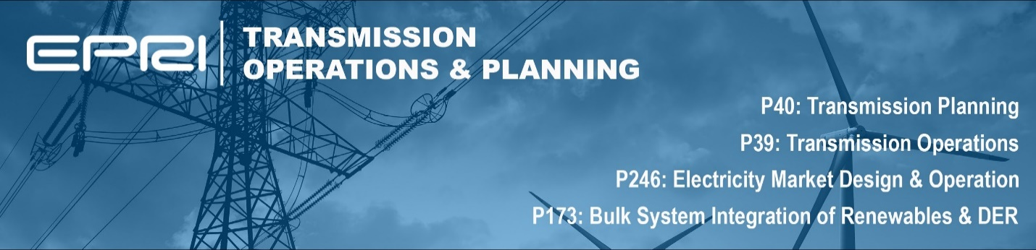

RECENT AND UPCOMING WEBCASTS
Below are the meetings and webcasts that have recently occurred for both the Task Forces and Programs. Recordings for past meetings can be found on the program cockpit by following the meeting material link below.

Date | Event | Link
Transmission Operations/P39
12-Dec-2024 | EPRI PS39A: " Real-time Operations and Situational Awareness" End of Year Webcast | Meeting Materials
04-Dec-2024 | EPRI PS39C: "System Restoration and Emergency Operations" End of Year Webcast | Meeting Materials
02-Dec-2024 | EPRI PS39E: "Monitoring, Analysis, and Control Using Synchrophasors" End of Year Webcast | Meeting Materials
19-Nov-2024 | EPRI PS39D: "Operations Planning and Engineering Support Studies" End of Year Webcast | Meeting Materials
15-Nov-2024 | EPRI PS39B: "Volt/Var Management and Power Flow Control" End of Year Webcast | Meeting Materials
14-Nov-2024 | EPRI PS39.A - Introducing aLLarMa - Using LLMs for Operational Data | Meeting Materials
06-Nov-2024 | EPRI ANNSTLF End of Year Webcast | Meeting Materials
Transmission Planning/P40
06-Dec-2024 | EPRI PS40C: "Methods and Frameworks for Advancing Transmission Planning" End of Year Webcast | Meeting Materials
05-Dec-2024 | EPRI PS40A: "Model Development, Validation, and Management" End of Year Webcast | Meeting Materials
05-Dec-2024 | EPRI PS40B: "Protection Methods, Tools, and Guides" End of Year Webcast | Meeting Materials
04-Dec-2024 | EPRI PS40D: "Special Assessments Supporting Transmission Planning" End of Year Webcast | Meeting Materials
20-Nov-2024 | EPRI PS40E: "Analytics for Emerging Transmission Planning Needs - HVDC Planning and Integration of GETs" End of Year Webcast | Meeting Materials
19-Nov-2024 | EPRI PS40B: Using CIM Standards for Exchanging Short Circuit Models between ASPEN OneLiner and Siemens PSS-CAPE | Meeting Materials
18-Nov-2024 | EPRI PS40E: "Analytics for Emerging Transmission Planning Needs - Advanced Reliability Tools and Analytics" End of Year Webcast | Meeting Materials
06-Dec-2024 | EPRI PS40C: "Methods and Frameworks for Advancing Transmission Planning" End of Year Webcast | Meeting Materials
15-Nov-2024 | EPRI PS40B: Using CIM Standards for Exchanging Short Circuit Models between ASPEN OneLiner and Siemens PSS-CAPE | Meeting Materials
12-Nov-2024 | EPRI’s Protection Settings Peer Review Tool: 2024 Updates | Meeting Materials
06-Nov-2024 | EPRI PS40B - TUTORIAL: CODING SIEMENS PSS-CAPE MACROS FOR PROTECTION STUDIES | Meeting Materials
05-Nov-2024 | Modeling and Model Validation Tools Interest Group Annual Meeting - November - 2024 | Meeting Materials
05-Nov-2024 | EPRI PS40B: Coding ASPEN OneLiner Scripts for Protection Studies | Meeting Materials
Bulk System Integration of Renewables and Distributed Energy Resources/P173
05-Dec-2024 | EPRI Project 173A Webinar "Advanced Numerical Solvers to Address Convergence Challenges of IBR Short Circuit Models” | Meeting Materials
03-Dec-2024 | EPRI PS173C: "Flexibility and Resource Adequacy Assessment" End of Year Webcast | Meeting Materials
22-Nov-2024 | EPRI P173A: "Modeling and Analytics for Emerging Technologies" End of Year Webcast | Meeting Materials
21-Nov-2024 | EPRI PS173B: "Operator Support Tools and Methods for Emerging Technologies" End of Year Webcast | Meeting Materials
14-Nov-2024 | EPRI PS173D: "Technology Transfer" End of Year Webcast | Meeting Materials
07-Nov-2024 | Load Forecasting for Resource Adequacy | Meeting Materials
Electricity Market Design and Operation/P246
03-Dec-2024 | EPRI P246: Market Operations and Design Advisors End-of-Year Webcast | Meeting Materials
19-Nov-2024 | 10th Annual ISO/RTO Market Design Technical Forum - Fall 2024 | Meeting Materials
05-Nov-2024 | EPRI Market Operations and Design Technical Webinar Series: Artificial Intelligence in Electric Power Systems and Electricity Markets | Meeting Materials

